**Setting Up Application Environment**

**Create an Account in Sendgrid**

|  |  |
| --- | --- |
| Date | 28 OCT 2022 |
| Team ID | PNT2022TMID17944 |
| Project Name | Skill and Job Recommender Application |
| Team Members: | Madhave Susheel S, Kirthika K, Nandhini R,Praveen V |

**Step 1:**

Go to official Sendgrid website: [***https://sendgrid.com/***,](https://sendgrid.com/) then click start for free.



**Step 2:**

Then go to Registration Page, you need to give all the details required for creating a Sendgrid account and finally click create button. The below screenshot will show the registration Process.

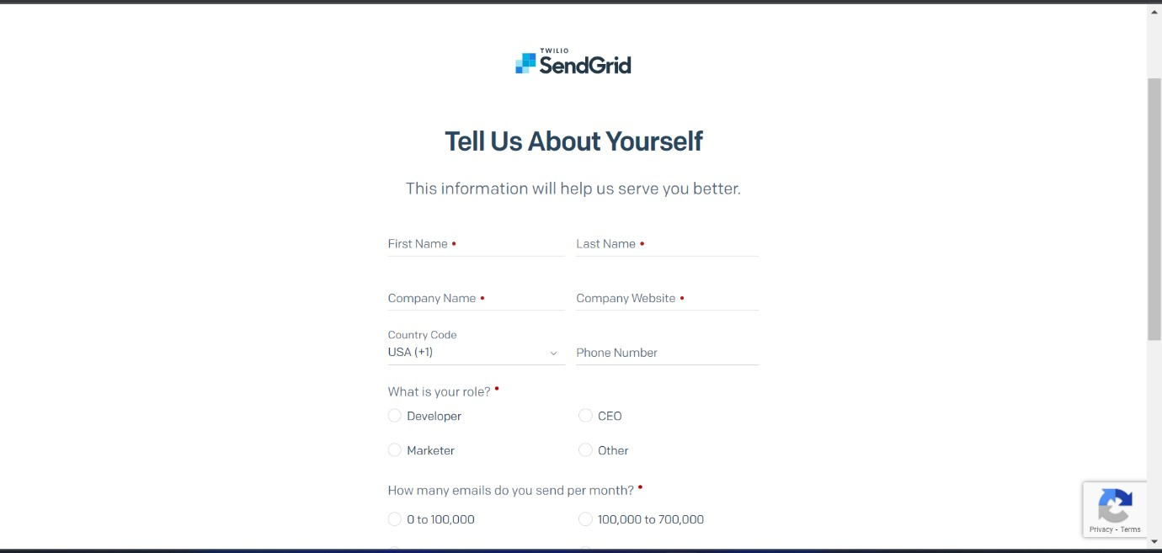

**Step 3:**

Then it will redirect you to a home page of your sendgrid account.

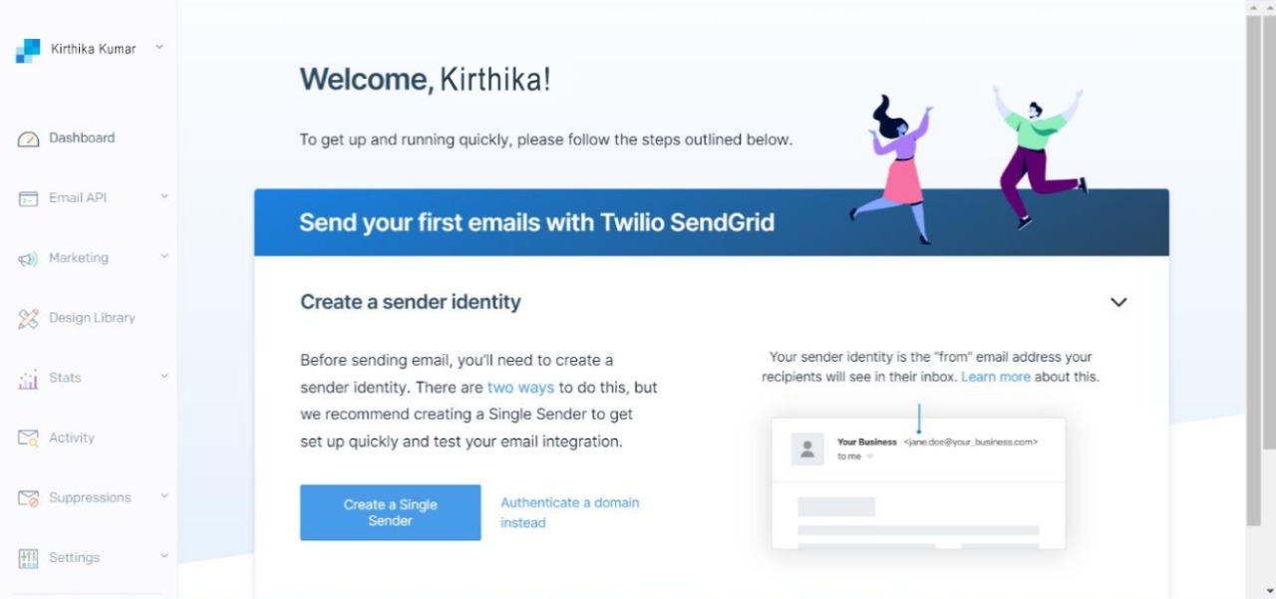

**Step 4:**

Finally, you have created your account and now you can access the sendgrid account.